TITLE OF PROJECT REPORT

OOPCGL MINIPROJECT
(TETRIS GAME)

Submitted By
ANSHIKA SINGH – 21204
PARTH ASAWA – 21205
PRANAV BHUTRA - 21210

Under the Guidance of
Prof. RUTUJA KULKARNI

Department Of COMPUTER ENGINEERING
PUNE INSTITUTE OF COMPUTER TECHNOLOGY
PUNE – 43

Aim :
To implement concepts of CG and OOP to construct an animation using any of the open-source software such as Qt Creator, blender, unreal engine, etc.

Objectives:
- To learn and use the open-source software to build an animation of short length.
- To learn how in real life the Concepts of CG and OOP re used.

Apparatus:
- Qt Creator
- MinGW Library

TETRIS GAME:
The object of the game is to stack the pieces dropped from the top of the playing area so that they fill entire rows at the bottom of the playing area. When a row is filled, all the blocks on that row are removed, the player earns a few points, and the pieces above are moved down to occupy that row. If more than one row is filled, the blocks on each row are removed, and the player earns extra points.
The Left cursor key moves the current piece one space to the left, the Right cursor key moves it one space to the right, the Up-cursor key rotates the piece counter-clockwise by 90 degrees, and the Down cursor key rotates the piece clockwise by 90 degrees.

This game can be created using only three classes:
- The Tetrix Window class is used to display the player's score, number of lives, and information about the next piece to appear.
- The Tetrix Board class contains the game logic, handles keyboard input, and displays the pieces on the playing area.
- The Tetrix Piece class contains information about each piece

2. TetrixWindow Class Definition
The TetrixWindow class is used to display the game information and contains the playing area.
We use private member variables for the board, various display widgets, and buttons to allow the user to start a new game, pause the current game, and quit.

  - TetrixWindow Class Implementation
This is used to display the score, number of lives, and lines removed. These initially show default values, and will be filled in when a game begins:
Three buttons with shortcuts are constructed so that the user can start a new game, pause the current game, and quit the application.

2.3 TetrixPiece Class Definition
The TetrixPiece class holds information about a piece in the game's playing area, including its shape, position, and the range of positions it can occupy on the board. Each shape contains four blocks, and these are defined by the coords private member variable.
2.4 TetrixPiece Class Implementation
The setRandomShape() function is used to select a random shape for a piece:
For convenience, it simply chooses a random shape from the TetrixShape enum and calls the setShape() function to perform the task of positioning the blocks.
The setShape() function uses a look-up table of pieces to associate each shape with an array of block positions.
The rotatedLeft() function returns a new piece with the same shape as an existing piece, but rotated counter-clockwise by 90 degrees

  - TetrixBoard Class Definition
The board is composed of a fixed-size array whose elements correspond to spaces for individual blocks. Each element in the array contains a TetrixShape value corresponding to the type of shape that occupies that element.
Each shape on the board will occupy four elements in the array, and these will all contain the enum value that corresponds to the type of the shape.
We use a Timer to control the rate at which pieces fall toward the bottom of the playing area.

2.6 TetrixBoard Class Implementation
In this ensure that keyboard input will be received. The first (next) piece is also set up with a random shape.
If a row contains no blank spaces, the rows above it are copied down by one row to compress the stack of pieces, the top row on the board is cleared, and the number of full lines found is incremented.
If some lines have been removed, the player's score and the total number of lines removed are updated.

Chapter 3
2D Transformation
This project consists of two classes and a global enum.
- The RenderArea class controls the rendering of a given shape.
- The Window class is the application's main window.
- The operation enum describes the various transformation operations available in the application.
3.1 Transformation operations
- Translation
- Scaling
- Rotation

3.2 Translation
Translation is to move, or parallel shift, a figure. We use a simple point as a starting point. This is a simple operation that is easy to formulate mathematically. We want to move the point P1 to a new position P2.
P₁=(x₁,y₁)=(3,3)
P₂=(x₂,y₂)=(8,5)
This means that translation is defined by adding an offset in the x and y direction: tx and ty:
x₂=x₁+tx
y₂=y₁+ty
We assume that we can move whole figures by moving all the single points. For a many-sided figure, a polygon, this means moving all the corners.

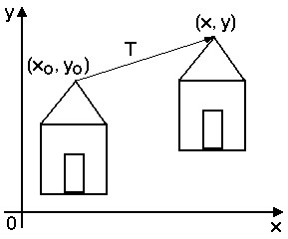
Figure 1: Translation in 2D
3.3 Scaling
To change the size of an object, scaling transformation is used. In the scaling process, you either expand or compress the dimensions of the object. Scaling can be achieved by multiplying the original coordinates of the object with the scaling factor to get the desired result.
Let us assume that the original coordinates are (X, Y), the scaling factors are (S_{X}, S_{Y}), and the produced coordinates are (X’, Y’). This can be mathematically represented as shown below –
X' = X. S_{X} and Y' = Y. S_{Y}
The scaling factor S_{X}, S_{Y} scales the object in X and Y direction respectively. The above equations can also be represented in matrix form as below −
(X′Y′) =(XY)[Sx00Sy]
OR
P’ = P. S
Where S is the scaling matrix. The scaling process is shown in the following figure.
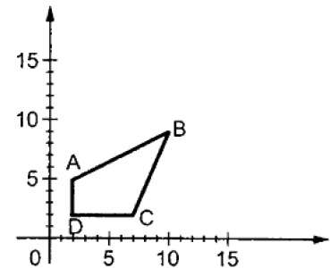
Figure 2: Object before scaling
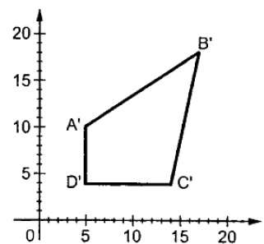
Figure 3: Object after scaling

If we provide values less than 1 to the scaling factor S, then we can reduce the size of the object. If we provide values greater than 1, then we can increase the size of the object.

3.4 Rotation
In rotation, we rotate the object at particular angle θ (theta) from its origin. From the following figure, we can see that the point P(X, Y) is located at angle φ from the horizontal X coordinate with distance r from the origin.
Let us suppose you want to rotate it at the angle θ. After rotating it to a new location, you will get a new point P’ (X’, Y’).
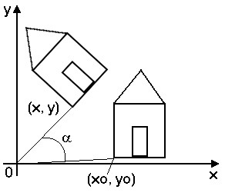
Figure 4 Rotation in 2D
Representing the above equation in matrix form,
[X′Y′]=[XY][cosθ−sinθsinθcosθ]OR
P’ = P . R
Where R is the rotation matrix
R=[cosθ−sinθsinθcosθ]
The rotation angle can be positive and negative.

Chapter 4
Screenshots:
